Welcome!

LibreOffice easy to use word processor. This processor allows you to easily create word documents, spreadsheets, and presentation. This processor is similar to Microsoft Office and offers the same technologies without having to pay any fee.

Getting Started
What you will need:
-a computer
-a stable internet connection



Downloading LibreOffice:
- Go to LibreOffice
- In the center of the screen you will see a “Download Now” in a green box, click.
- Click on the “Download Version 4.3.0”
- Unless you wish to donate your money, disregard the screen and focus on the application downloading at the bottom of the screen (See photo 1 below.)
- I box should pop up, drag the LibreOffice icon into the applications folder.
- Locate libreoffice within applications folder, open it.
- You are now ready to being a project. See below options to learn about some of the word processing options available. (See photo 2 below.)

Photo 1
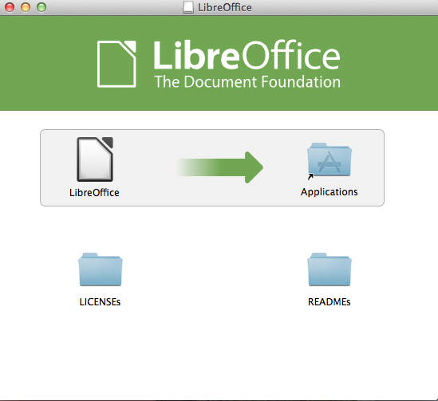

Photo 2
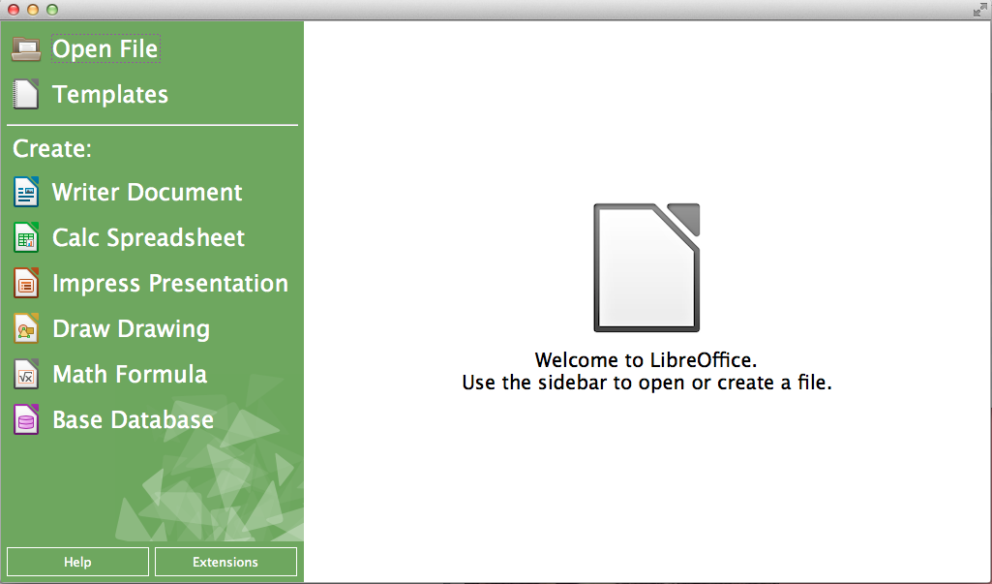

How to Write a Letter with LibreOffice Writer:

What You Will Need:
-Your contact information and address
-Recipient’s contact information and address
-Understanding of appropriate letter writing format (Reference Photo 2 for additional help)

Writing A Letter in Writer:
- Click on “Writer document” on the left hand column of the opening screen of LibreOffice
- Start by clicking the “Align Right” Button (Reference Photo 1). One line at a time input your name, email, telephone, and any other important contact information.
- Underneath your contact information, type in the date.
- Hit Enter/Return on the keyboard, and change alignment to “Align Left.”
- One line at a time, input the recipient’s address and other contact information.
- Hit Enter/Return on the keyboard twice to separate the contact information from the beginning of your letter. Now it is time to address the recipient with “Dear (Name),.”
- The “Dear” line should be on its own line.
- Below the “Dear” line is where the information you wish to discuss belongs.
- The final paragraph of your letter should sign up your main points and thank the reader for their time.
- Separate your signature from the rest of the letter by hitting enter/return twice.
- Sign with an appropriate sign off such as “Sincerely” or “Best Regards.”
- Be sure to save your work by going to the “File” then “Save As” option and saving your work with an appropriate name.
Photo 1
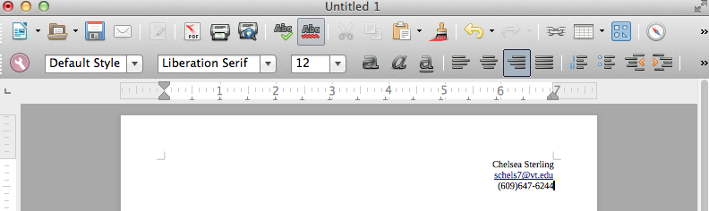
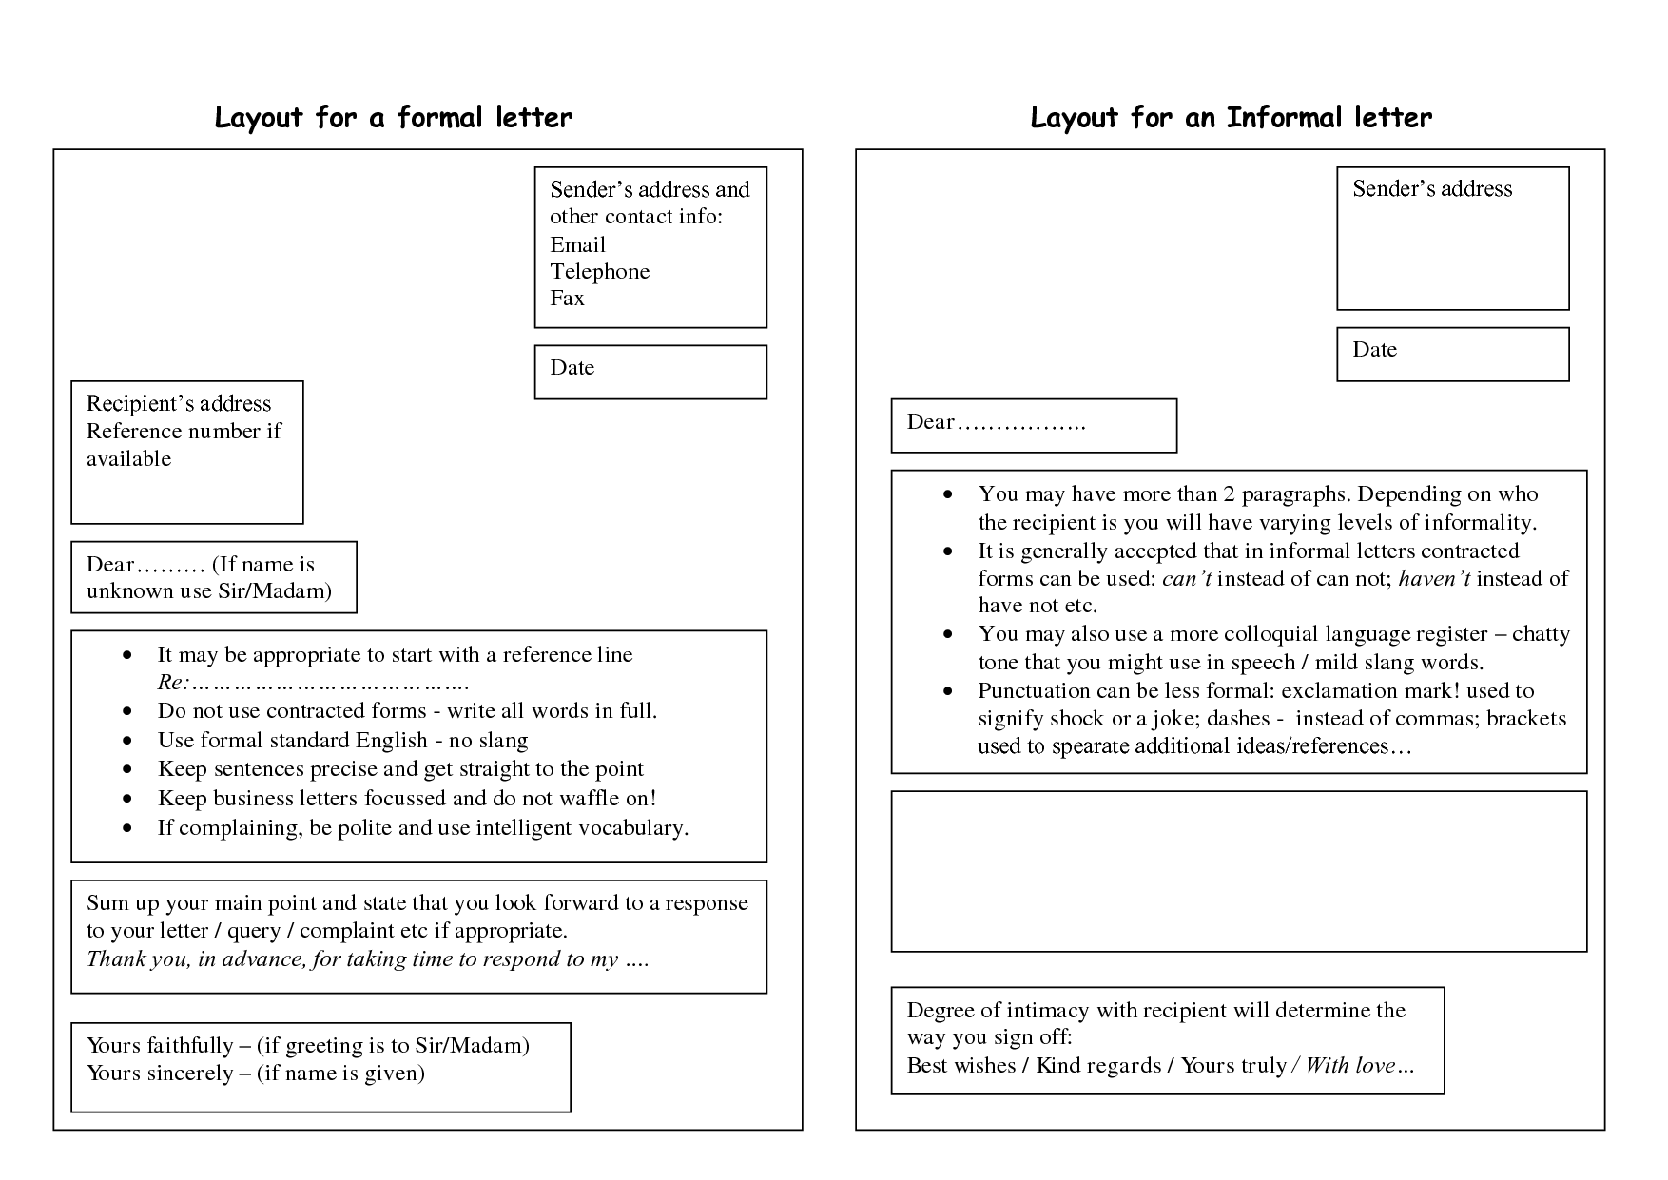
Photo 2

How to Create a Simple Spreadsheet in LibreOffice Calc:

You will need LibreOffice to perform the following task.
For this example I have used information about how many apples and oranges a classroom of students ate during the school week.

Creating a Spreadsheet:
- Open LibreOffice and click “Calc Spreadsheet” to open a new spreadsheet.
- Enter the data you wish to compute into the spreadsheet. For this example I have used information about how many apples and oranges a classroom of students ate during the school week.
- As you can see in Photo 1, if you wish to perform a mathematical function, you must first type “=” into an empty cell. In this case, I wanted to know how many total apples were eaten in this week, so I highlighted all the apples eaten this week by clicking each cell and holding down the command button.

Impress

